中国大学MOOC课程
课程推荐
1
https://www.icourse163.org/category/programminglanguage#?type=30&orderBy=0&pageIndex=2
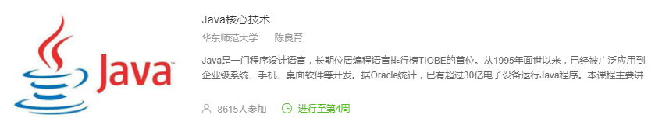

2
https://www.icourse163.org/category/programminglanguage#?type=30&orderBy=0&pageIndex=3
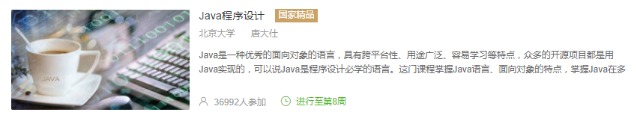

3
https://www.icourse163.org/category/programminglanguage#?type=30&orderBy=0&pageIndex=4
